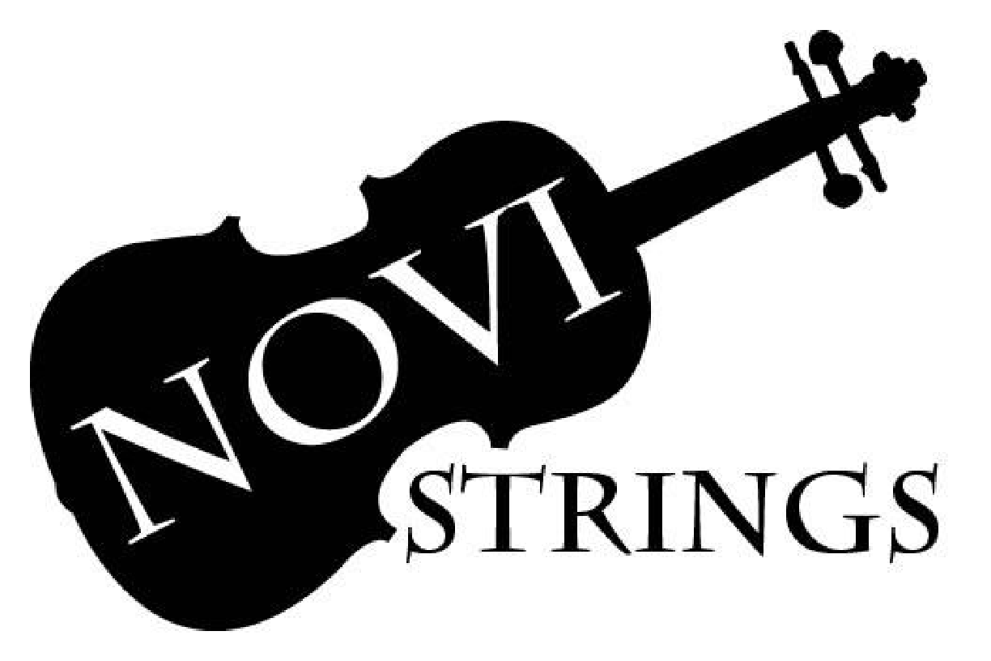

Welcome,
I am greatly looking forward to this school year and all the opportunities to learn and create music with the orchestras at Novi Middle School. Please find below information about our program, some basic guidelines and concert dates.

Communications & Social Media

Ms. Hickey’s contact information:
248-449-1600 ex. 6602
samantha.hickey@novik12.org

Orchestra Website
www.novimsorchestra.weebly.com
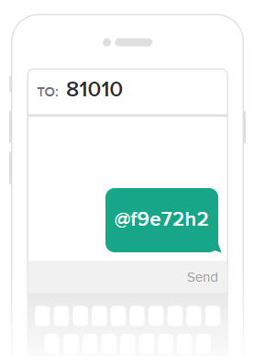
Please check out our orchestra website and visit it regularly for important information, handouts, announcements, educational links etc. There is also a link to this webpage from the Novi Schools webpage, found in the performing arts section or on the middle school page.

Novi MS Orchestra Twitter Page
@NoviMSOrchestra
Follow our twitter page for reminders and updates throughout the year!

Remind
This year, we will be using the Remind app to send out special reminders for concerts, weather announcements, etc. This can be used for students and parents alike! To join remind, simply text @f9e72h2 to 81010.

Emails
Mass email reminders are sent throughout the year via MiStar. Parents, please make sure the email on file for you in MiStar is up to date!

Course Information

Seventh Grade Concert Orchestra
This intermediate level orchestra is suggested for students with one or two years of experience playing a stringed instrument. Students will work on developing good tone quality, bowing techniques, recognizing and performing different styles of music, increasing technical and rhythmic skills and developing as individual and ensemble musicians. Numerous opportunities to perform in concerts, solo and ensemble festivals, assemblies and community events will be provided. Students may also elect to switch instruments based on orchestral needs (viola, cello, double bass).

Eighth Grade Symphony Orchestra
The concert orchestra will learn and perform music at a higher level of musicality and technical difficulty. Students will continue to build upon their fundamental skills in tone quality, bow techniques, recognizing and performing different styles of music, increasing technical and rhythmic skills and developing as individual and ensemble musicians. The concert orchestra will have numerous opportunities to perform in concerts, festivals, solo and ensemble, assemblies, and community events.

Materials List

- Padlock for instrument storage locker (violin and viola students)
- Three-ring binder (recommended) or a folder for your music and materials
- Tab dividers for binder (recommended)
- Pencils
- Violin/Viola: instrument, bow, shoulder rest, rosin, tuner, metronome
- Cello/ Bass: instrument, bow, rock stop/endpin strap, rosin, tuner, metronome

Grade Requirements

Practice/Participation = 20%

Students are expected to practice five days per week. Students will receive a practice log in class with instruction on how to fill it out. Practice tips and time management ideas will be discussed in class. In the event that a student is unable to complete the required amount of practice due to special circumstances (i.e. illness, vacation etc.) a note from a parent/guardian will excuse the student from the affected practice record.

Certain activities in class count towards participation credit. If a student does not participate, they will lose credit for that activity.

Concert & Rehearsal Attendance = 40%

Because each person is an important part of the group, all performances are required in order to meet the academic expectations of the class. Concerts are a way for students to exhibit what they have learned over the course of the year, and are a vital part of each student’s music education. Performances are a unique experience that cannot be re-created. Since unexcused absences from a performance cannot be tolerated, a student’s overall grade will be lowered by a maximum of one letter grade. The director may consider special circumstances for absence. Written excuses from the parent must be submitted at least 3 weeks prior to a performance. Emergencies and illness will be treated on an individual basis, but generally an illness excuse must be presented to the teacher as soon as possible or WITHIN 24 hours of the missed performance. Improper notification could result in an unexcused absence.

Students are also expected to attend full rehearsals as the three 7th grade classes will combine to perform in concert and the two 8th grade classes will also combine to perform in concert. In preparation for each performance, we will have 1-2 after school rehearsals. These will take place at the middle school. As these are the only combined rehearsals it is mandatory for all students to be in attendance. Students should speak with their coaches to make accommodations for these rehearsals. Students will only be excused from the orchestra rehearsal for school sports related reasons in the event of competition. In order to be excused from an orchestra rehearsal, the student must communicate with Ms. Hickey as soon as the student knows about the conflict and at least 1 week prior to the rehearsal. Cello and bass students should make arrangements to bring their instrument from home on the days of after school rehearsals.
**Excused absences from a concert or rehearsal need to be made up. An individual who finds himself/herself in this situation needs to make an appointment with the director to determine a make-up assignment

Assignments & Assessments = 40%

Through the year, there will be written assessments, playing assessments or rhythmic interpretation assessments. Assignments to be completed in class or as homework may be in the form of practice, written assignments or Smart Music assignments (in class).

**Students who need additional assistance on their orchestra instrument should make an appointment with the director to seek help before or after school or during A20.

Additional Information

Concert Dress

Black Dress Pants
White Dress Shirt
Black Socks
Black Dress Shoes

*Black jeans or athletic pants are not acceptable. Tennis shoes are not acceptable.
**Improper concert dress will result in the student not being allowed to participate in the concert and therefore receiving a zero in the gradebook for the concert.

Private Lessons

Private lessons are strongly encouraged for all orchestra students. A student working independently with a teacher can develop individual skills; learn solo music, and other repertoire specific to their instrument. Moreover, private lessons help students develop the skills necessary to be successful musicians. A private teacher list is available in the orchestra room and recommendations can be made upon request.

Music
Each student will need a binder or folder to keep their music and class materials in. This binder is to go to and from school on a daily basis. Students are responsible to keep track of their music and have it in class. Do not rely on your stand partner to have theirs, as they may forget or be absent. Students are responsible for returning music in acceptable condition at the end of the school year and will be required to pay for lost or damaged music. Sheet music and rehearsal books take the place of textbooks for other classes.

Lockers
Each violin/viola student is assigned an instrument locker at the beginning of the school year. Students are responsible for providing locks to secure their lockers. This is to prevent lost or stolen items. Novi Middle School cannot be held responsible for items missing from an unlocked locker. Please provide the combination for you lock to the director. This information is kept confidential and is only used if a student forgets their combination.

M.S.B.O.A. Performances

Michigan School Band and Orchestra Association Band Festival
Every spring the ensembles will participate in the District 4 MSBOA Band and Orchestra Festival. The students perform a planned program and sight read new music for a panel of judges who comment on the areas for improvement and strengths of the ensemble. The attendance policy is the same as for other performances.

*Please note that festival will fall on a Friday evening or Saturday. There is no time or location listed because we do not receive that information until 2-3 weeks prior to the event. Please leave the entire day available.

Solo and Ensemble Festival
Students will have the opportunity to perform at Solo and Ensemble Festival in December. At this event students will perform a solo, in an ensemble, or both in front of a judge. Students will receive feedback on their performance and a rating of I-V (a I is superior). Those students that receive a rating of I or II earn a medal. Students usually find the experience to be quite rewarding, even though it may be a little intimidating the first time.

This year we are hosting Solo & Ensemble festival at NMS. We will need LOTS of help in preparation for and during the event. Please look for more information, coming soon.

Respect and Responsibility Policy
In the Novi Middle School Orchestra Room, we work under the expectation that all students have a right to learn and all teachers have a right to teach. The following classroom expectations are to support that expectation.

Classroom Expectations
- Absolutely no talking when the teacher is working
- All music making stops instantly when the teacher gives the signal
- Be Respectful and Prepared
- No Gum, Food or drink in the classroom (water bottle is ok)
- Leaning on music stands is not permitted.

*This class may NOT be recorded (audio, visual, or audio-visual) without the written consent of the course instructor.

We’re looking forward to a great year!

Please Sign and Return By___________________

By signing below, you are signifying that you…

…have read and understand the contents of this handbook.
…agree to follow the guidelines found within.
…have posted important dates on your calendar and understand the attendance policies.

STUDENT INFORMATION

Student Name:__________________________________________________
Student Signature:______________________________ Date:_____________

Parent/ Guardian (s) Name:__________________________________________
Parent’s Signature:______________________________ Date:_______________

Request for chaperones and parent volunteers will be sent out throughout the school year. If you are interested in helping with orchestra needs, please send Ms. Hickey a note or email.

Mass email reminders will be sent out using the email you provided in MiStar. Please make sure the email you provided is up to date!
PARENT INFORMATION

